Multiple Google accounts on one device:

The current google account can not be edited – In the same manner as trying to edit your own google account on your laptop – You will not be able to change your email address – but you can always create a new account ( email address).

This is the quickest, most simple way to add another Google Account:

- Open Google Playstore on your device
- Tap the menu button on the device
- Select "Accounts" from the list.

A new window will open, showing the current active Google account in use on your device. You can add a secondary google account instead of trying to edit the current google account.

- If the account you want to use is not listed, tap the "Add account" button
- Follow the prompts to add a new or existing Google account.

Use the new account as your default Google Account.

.
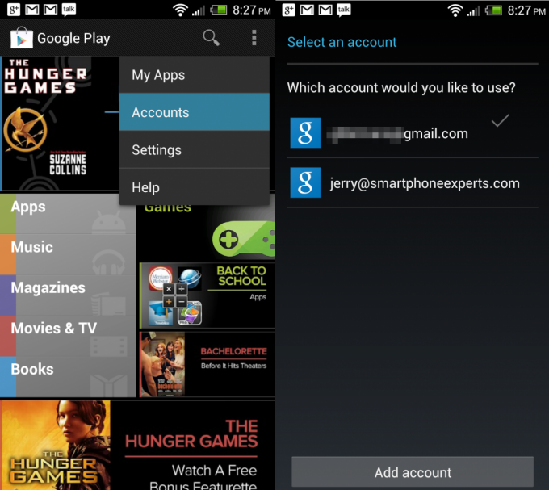

Application Menu:
Select ACCOUNTS

Google Accounts Menu:
Select ADD ACCOUNT
Alternative Method:

Adding and Removing accounts:
You can add multiple Google Accounts and Microsoft Exchange ActiveSync accounts. You may also be able to add other kinds of accounts, depending on your applications.

Add an account

- Open the Accounts and Settings Screen
You can do this in Contacts by pressing Menu and touching Accounts, or directly in the Settings application.
The Accounts & Sync Settings screen displays your current sync settings and a list of your current accounts.
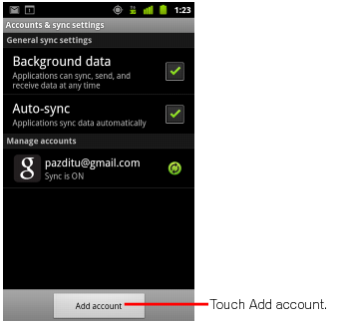

- Touch ADD ACCOUNT
- Touch the kind of account you would like to add: In this case: Select GOOGLE
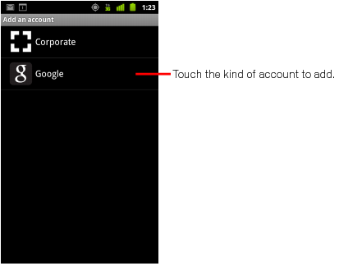

- Follow the on screen steps to enter the required information about the account

You will now have more than one google account listed in your accounts list.

How to Remove an Account:
You can remove an account ( excluding the original google account to delete it and all information associated with it from your phone, including email, contacts, settings, and so on.
You can’t remove the first Google Account you signed into on the phone, except by deleting all personal information from your phone.
- Open the ACCOUNT SETTINGS screen:
  - You can do this in Contacts by pressing Menu and touching Accounts, or directly in the Settings application.
The Accounts & Sync Settings screen displays your current sync settings and a list of your current accounts.
- Touch the Account to delete
- Touch REMOVE ACCOUNT ( if the REMOVE ACCOUNT option is not on your device – touch SIGN OUT.
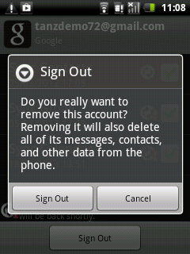

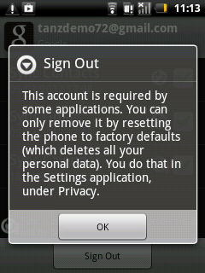
If you try and delete the original account that you used to setup the phone - you will receive the following message:

Factory Data Reset

To delete the original Google Account you will need to do a Hard Factory Reset:

The original factory settings can be restored by:

Go to: Phone Settings > Privacy > Factory data reset > Select RESET PHONE

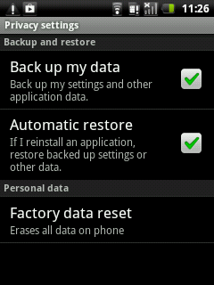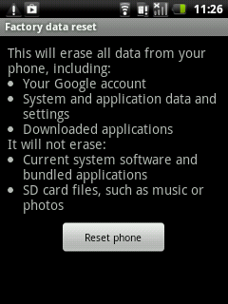

Please note that a Hard Factory Reset will clear the phone and leave it as a brand new device –
ready for re-installation.

All Personal data including including information about your Google Account, any other accounts, system & application settings and any downloaded applications will be cleared.

