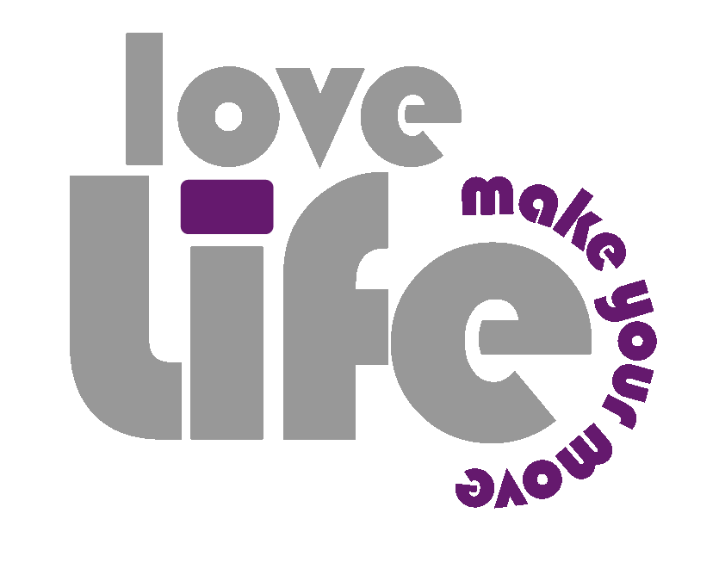
APPLICATION TRAINING GUIDE
FOR GROUNDBREAKERS

JANUARY/FEBRUARY
2012

TABLE OF CONTENTS

- Introduction
- Launching loveLife & User Verification
- Application Menu
- Flagged Reports
- Pending Reports
- Registrations & Linking Data
- Teams
- Data Synchronisation
- Conclusion

Introduction

Congratulations on completing the Samsung Pocket Device Training.
Now it is time to focus on the actual application: The loveLife Mobile Monitoring Application.
This application is installed (you installed it!) on your Samsung Pocket.
At first the application will be strange to you .. as with anything new. Your Regional Programme Leader will take you through the start-up procedure and the user verification process.
Thereafter he/she will explain the application menu to you. If you understand the menu and what each menu item is for, then you are more than halfway there!
After explaining the main menu, your RPL will tell you about Reports and Registrations. He/She will take you through some examples and it is up to you to practise and become familiar with your new role as a loveLife groundBreaker.
Have fun with the training and remember there is no such thing as a stupid question!

Launching loveLife & User Verification
You have already learnt how to install the loveLife application and how to add an application icon to your Device Home Screen. You have also enrolled yourself as a groundBreaker on the device.
It is very easy to open the loveLife application. Tap once on the loveLife icon on your home screen. This will take you to the User Identification Screen.
You are a groundBreaker, so please select: groundBreaker. The next screen will ask you to confirm if the details displayed is YOU. If it DOES NOT display your name, report this to your RPL. IF it IS YOU, tap NEXT to go to the APPLICATION MAIN MENU.
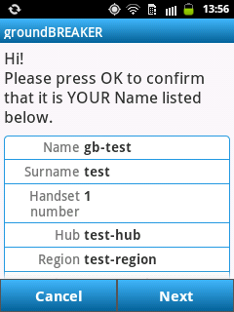
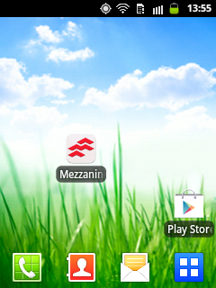
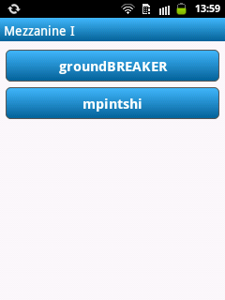
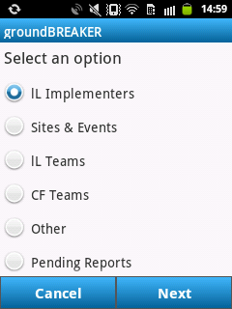

Application Menu
The most efficient way to navigate within an application is obviously when you know where to go to do what you need to do.
loveLife has a very simple user friendly application menu.
If you understand the menu, it should always be easy to do your tasks because you will always know where to begin. After that the application will guide you to the next step.

The Application Menu:

The Samsung Pocket is has a very user friendly interface and the touch functionality will be far better than what you are probably used to on a touch screen.
When selecting a menu option – ALWAYS tap NEXT to go to the next screen. Tapping the menu option does NOT automatically take you to the next screen.
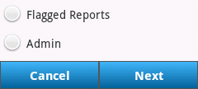

Menu Options Explained
IL Implementers
Q: What is a loveLife Implementer?
A: You are a loveLife implementer. A person that manages events or a person who is required to assist with events is an implementer for loveLife.
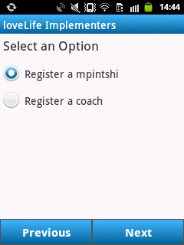

A groundBreaker (gB for short) will be able to register two types of loveLife implementers:
- a Mpintshi
- a Coach

These implementers will assist you on site and at events.
Sites & Events
The job of a loveLife groundBreaker is to collect data – You will be registering implementers, schools and different types of sites where you will be holding your events.
When you register a new school, you will always FIRST do a search to see if the school has already been registered. The loveLife application is connected to the Education Management Information System (EMIS). Every school has a unique EMIS number. Use this School EMIS number to search the national schools database.
The chance that your school is in EMIS is very good. On the rare occasion where the school cannot be found, you can go ahead and REGISTER a new school.
In the case where you can find your school in EMIS, simply select it to link it to your Site Event.
Your RPL will go through all the Sites & Events menu options with you. Remember to ask questions if you are confused.

The Sites & Events Menu:

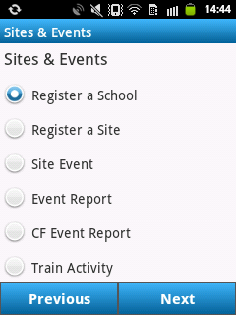
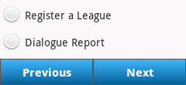
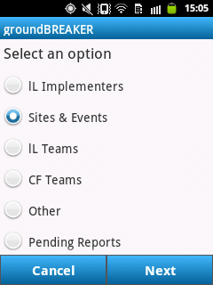

loveLife Teams
At times you will not be doing events at schools, but rather with teams.
The loveLife team consists of all the loveLifestyle programs.
All the loveLife style and sports participants are registered as loveLife team participants. Only Arts & Culture participants will NOT be registered under loveLife Teams. They will be registered as a Cultcha Factory Team (Explained in the next section)

All teams need to be registered. You also need to log the attendance of your Team Event and after the Team has successfully completed the event – The people in the Team GRADUATE.
To manage a loveLife Team Event, select lL Teams from the Main Menu.

The loveLife Teams Menu:
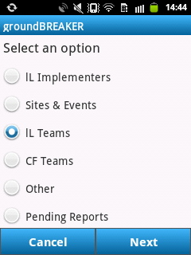
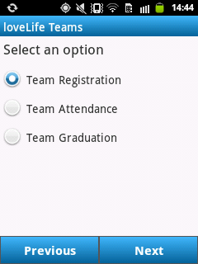

CF Teams
Managing the Cultcha Factory Teams is exactly like managing the loveLife Teams. The Cultcha Factory Programmes are focussed on the Performing Arts. When there are arts & culture participants, we will register them under CF TEAMS.
You also need to log the attendance of your Team Event and after the Team has successfully completed the event – The people in the Team can GRADUATE.
To manage a Cultcha Factory Team Event, select CF Teams from the Main Menu.

The Cultcha Factory Teams Menu
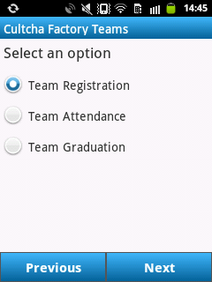
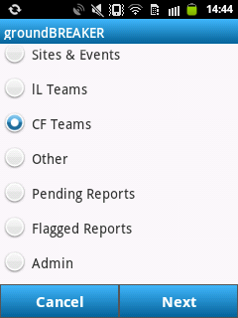

Other (Y-Centre Menu)
This menu option is specifically for the groundBreakers that will be working at the Youth Centres, also known as Y-Centres.
You will be conducting all your events at these Youth Centres.
To go the Youth Centre Headcount option, select OTHER from the Main Menu and select Y-Centre Headcount.
Very Important: All Y-Centre groundBreakers need to register every young person that comes into the Youth Centre.
The menu option is exactly what it says: Count the heads coming through the Y-Centre.

The Other Menu:

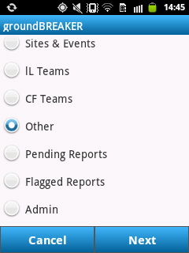
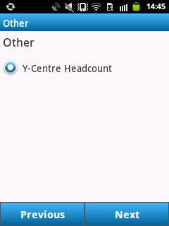

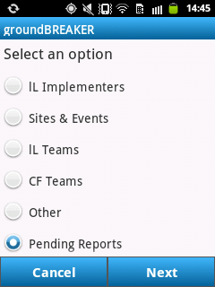
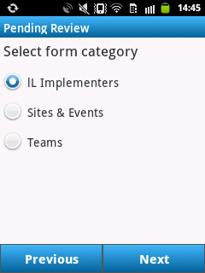
Pending Reports

The Pending Reports Menu:
Pending Reports are discussed and illustrated in more detail a little bit later in your training.
To go to PENDING REPORTS, select PENDING REPORTS from the Main Menu.

Flagged Reports
The Flagged Reports Menu:
Flagged Reports are discussed and illustrated a little bit later in your training. Flagged Reports are forms that you need to make corrections on.
To go to FLAGGED REPORTS, select FLAGGED REPORTS from the Main Menu.

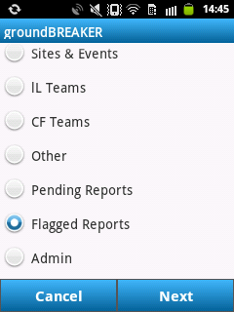
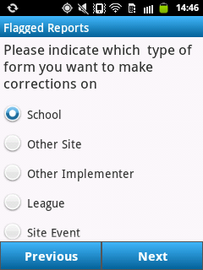
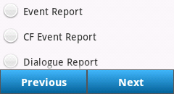

Administration
The Administration Menu allows you to view your Performance. You can also submit a Support Request to your RPL from the Administration Screen.
You can also log your GPS co-ordinates of the site you are visiting from this screen.
To access the Administration Menu: Select ADMIN from the Main Menu.

The Administration Menu:
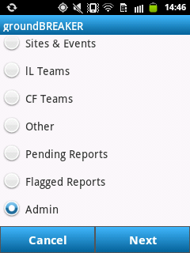
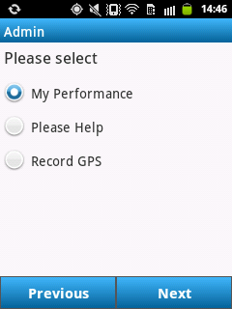

Viewing your Performance:
From the Admin menu, select MY PERFORMANCE. There will be several options to choose from on the next screen – for this example we select OTHER SITE. Click on NEXT to view your Performance.
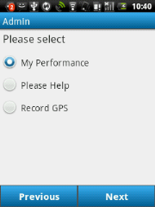
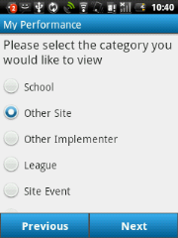
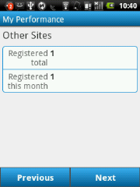
This Example: The gB has registered one OTHER SITE this MONTH and no other sites. Therefore the Registered Total is: 1

Flagged Reports (Forms)
When you capture data on your device, all this information is sent to our server. Your RPL will receive this data in the form of a report.
Your report could either be correct or it could be incorrect. When your report is incorrect, your RPL will FLAG the report by sending you a message in the loveLife application to CORRECT the report and SUBMIT your report again. When your report is completed correctly, your RPL will APPROVE your report.
How to check for Flagged Reports: When you open the loveLife application, and you have completed the user verification, the next screen will TELL YOU if you have flagged reports. If you do, go to FLAGGED REPORTS in the Main Menu and follow the example below: This groundBreaker made a few mistakes when he wanted to complete a Team Graduation. The RPL sent a message to him and the gB now has the opportunity to correct and complete this Team Graduation successfully.
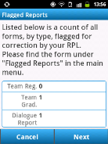
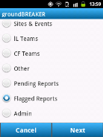
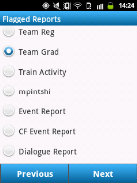
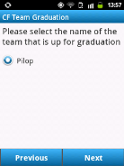
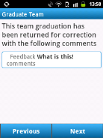
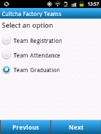
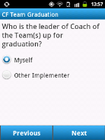
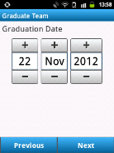
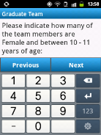
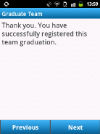

Pending Reports
Now that you have re-submitted the Team Graduation form to your RPL, this information lies on the server waiting for the RPL to check that you have completed the form (report) correctly this time.
You would also like to know if your RPL has checked your report. While your report lies in wait, we call this status: PENDING (waiting to be REVIEWED by your RPL)
How to check if you have Pending Reports:
From the Main Menu, you need to select PENDING REPORTS. You know that you re-submitted a Team Graduation Form. So it will not help if you go and check for a pending report under SITES & EVENTS. We should rather check under teams. Remember to always tap on NEXT to go to the next screen.
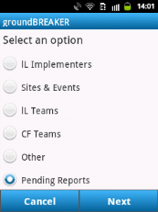
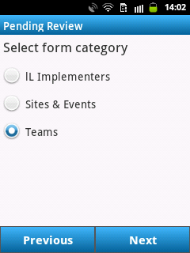
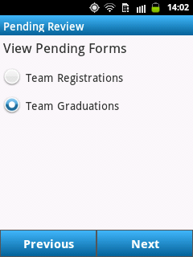
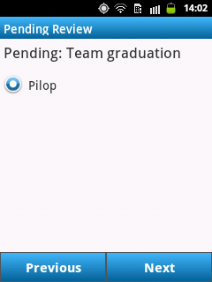
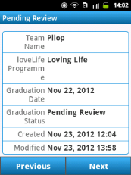
Registrations & Linking Data

People (Implementers) and Places (Sites) need to be registered first BEFORE you can manage an event.
Example: We are at a school where a school coach will be helping you manage your Aids Education Campaign. You cannot complete all the questions and answers in your campaign if you have not registered the coach and the school BEFORE you started with the campaign.
In these campaigns that you will become very familiar with you will always find a section in the questionnaire where you need to SELECT the COACH and the SCHOOL from a list.
You can only select (in this example) the coach and the school IF you registered them beforehand. You will need to redo your whole questionnaire if you forgot to register the coach and the school.
This is not a situation you would like to be in when you are busy managing an event:
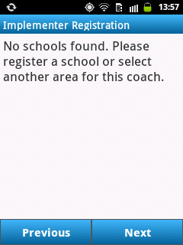

Example:
How to Register a Coach: Please go through the simple steps in the illustration on the next page.
Note that some of the screenshots are HORIZONTAL. That is because of your Pocket’s AUTO ROTATION functionality. If you don’t like this, remember that you can turn it ON and OFF in the Device Status Panel.
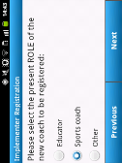
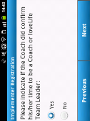
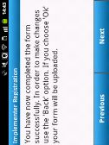
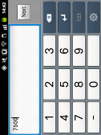
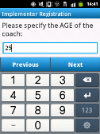
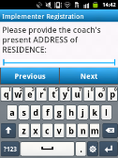
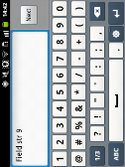
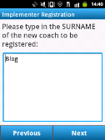
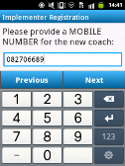
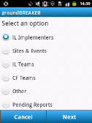
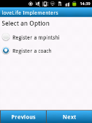
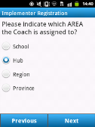
How to Register a Coach:

From the Main Menu, select lL IMPLEMENTERS. Because we are registering a COACH, select REGISTER A COACH on the next screen. In this example the coach is linked to a HUB. You need to enter all the information on the Implementer Registration screens. Please do not leave any information blank or enter junk data into the fields if you do not know the answer. There will be someone that can help you, when in doubt – ask your RPL what to do.
Teams
You will be registering TEAMS. You also need to keep track of teams by taking ATTENDANCE. After the TEAM has completed your event, the TEAM will GRADUATE.
It is very important to complete the Attendance Register. We need to know how many participants were at your event.
After registering your team you would typically record how many individuals there were per age group for male & and female. It is compulsory to take attendance at your event. You need to complete personal details such as Name, Age and Gender for each module/session.
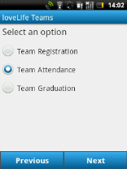
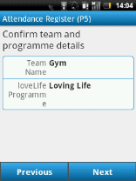
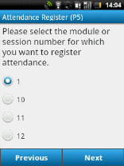
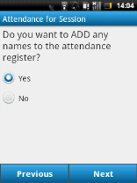
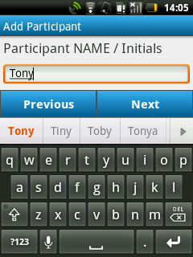
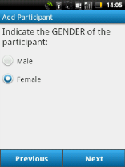
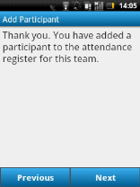
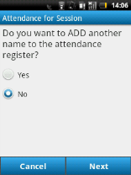
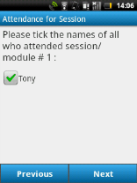
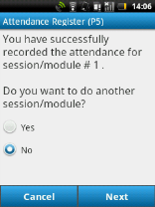
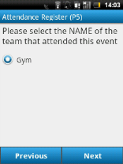
The illustration below shows you exactly how to enter Team Attendance detail:

Data Synchronisation
Q: What does Data Synchronisation mean?

A: The term “Data Synchronisation” refers to a process that mostly occurs automatically. Every time your device sends data to the server or receives data from server,“data sync” happens. Data that is in sync simply means that the data you can see on your device is exactly the same on the server at the same time.

Q: I was capturing data in an area with a bad signal. I am not sure if my device data is in sync with the server. What can I do to ensure that my data is sent to the server?

A: You can open the “In Application” Menu by clicking on the MENU button. You will see a new menu appear that has the SYNCHRONIZE option in the top left-hand corner of the menu. Touch the Synchronize menu item once to start the synchronisation process between your Pocket and the loveLife Server.

Note the SYNCHRONIZE icon at the top left hand corner of your Status Bar: It will be animated until the sync is complete.

Q: How will I know when my sync is complete?

A: The sync icon will disappear from the top left-hand corner of the Status Bar

Q: How will I know when a sync attempt was not successful?
A: After you’re synchronisation attempt failed, you will see a notification icon in the Status Bar. Swipe down on the Status Bar to access the Notification Panel. You will see an error message stating that the Synchronisation failed.
Try synchronising again when you reach an area with GOOD signal.

Q: What is the “DIAGNOSTICS” icon in the IN APPLICATION MENU for?
A: This menu option is for advanced users to monitor their device system performance, view processes and monitor device tasks. PLEASE DO NOT TOUCH.

Q: I touched “DIAGNOSTICS and see that there is an option CLEAR CACHE. What does it do?
A: Sometimes your device will be slow and you need to free up some resources so that it can provide best possible performance. The CACHE is a temporary data storage facility on the device. When too full it can hamper performance. Don’t clear the CACHE unless your RPL tells you to!

The next page illustrates how you can manually start the synchronize process.

- Click the MENU button to open the IN APPLICATION MENU
- Touch the SYNCHRONIZE icon the IN APPLICATION MENU
- Note the Status Bar: A new sync icon will appear
- On sync complete: Sync Icon will disappear.

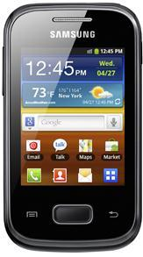
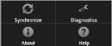
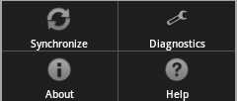

Conclusion
Congratulations! You have completed your groundBreaker training.
In the first half of your training we covered Device Specific Training. This manual takes care of the loveLife application part of your training.
Please keep both User Guides close by. The Samsung Pocket is a very friendly device and the loveLife application is just as easy to work with.
There is a big difference between practising in the training environment where your RPL is with you and going out to schools where you will have to manage an event with sometimes 100’s of people attending all on your own – where people assisting you come to YOU for advice.

To make life easier for yourself:
Be comfortable with the loveLife processes, look after your Pocket, keep it charged, pay attention when completing questionnaires and filling in any other forms.
Be pro-active and send correct information to your RPL. Less flagged reports means less corrections that you need to make. Ask your RPL for support when you need it. Don’t wait.
The better you know your Pocket and the better you know how to use the loveLife application – The more fun you will have being a groundBreaker!

Thank you for attending the training and GOOD LUCK!

